Machine Learning

Business Report

August 2021

This Business Report shall provide detailed explanation of how we approached each problem given in the assignment. It shall also provide relative resolution and explanation with regards to the problems

Thakur Arun Singh

Contents

Problem 1: 2

Problem 1.1 2

Problem 1.2 4

Problem 1.3 12

Problem 1.4 14

Problem 1.5 15

Problem 1.6 16

Problem 1.7 17

Problem 1.8 38

Problem 2: 39

Problem 2.1 39

Problem 2.2 40

Problem 2.3 42

Problem 2.4 43

## Problem 1:

You are hired by one of the leading news channels CNBE who wants to analyze recent elections. This survey was conducted on 1525 voters with 9 variables. You have to build a model, to predict which party a voter will vote for on the basis of the given information, to create an exit poll that will help in predicting overall win and seats covered by a particular party.

### Problem 1.1

Read the dataset. Do the descriptive statistics and do the null value condition check. Write an inference on it.

**Resolution:**

First, we import all the necessary libraries seaborn,numpy,pandas,sklearn etc to perform our analysis

Next, we import the data set “Election_Dataset_Two Classes”

**Head:**

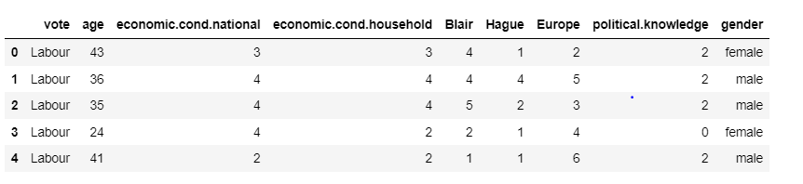

**Tail:**

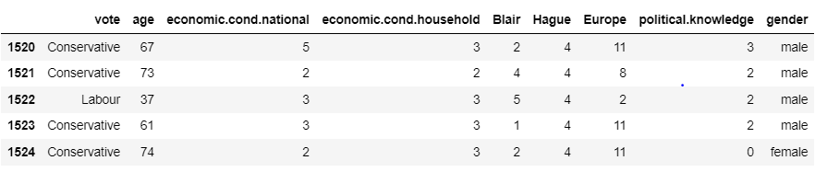

* By looking at the data, the first column can be removed since it is not of much significance.
* In Total, we have 9 columns which are valid to perform our analysis.
* All 8 features are Independent variable whereas 9th Feature vote is dependent variable.it is basically Target variable model wants to predict. All features except vote and gender are Numerical. Vote and gender are Nominal Categorical.

**Data description:**

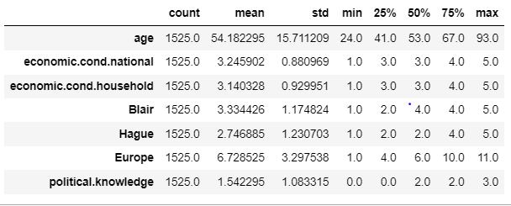

* In above description we can see mean values and 50% are almost same, mean and median are almost Coherent.
* Gender and vote seems to be Categorical Nominal variables, where order is not important aspect
* All other variables are Categorical Ordinal Variables, Ratings
* All features seems to be somewhat equally distributed around mean.

**Information about the data:**

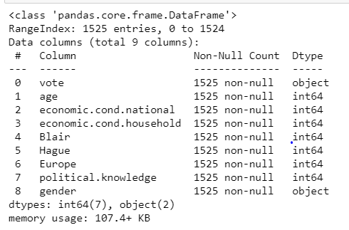

We can see gender and vote are of Object Datatype, we will try to convert it into integer Data type further.

Total 1525 data points are there, 1525 different people, No null value can be detected here.

**Checking null values:**

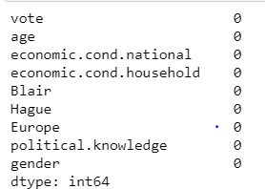

No null values present in the data set.

**Checking for any duplicate records:**



We will check manually whether these are exact duplicates or partial duplicates.

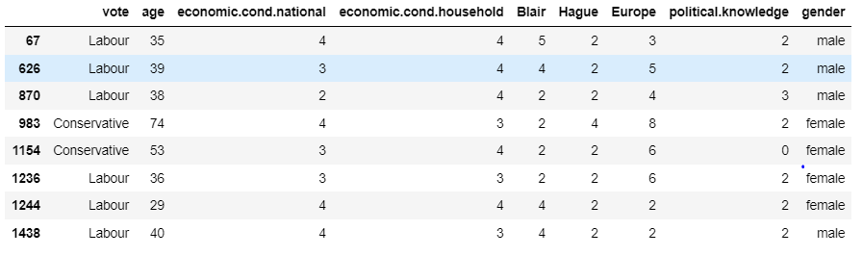

**Shape of the data:**

Shape of the dataset is 1525 rows and 9 Columns.

### Problem 1.2

Perform Univariate and Bivariate Analysis. Do exploratory data analysis. Check for Outliers.

**Resolution:**

**Univariate Analysis:**

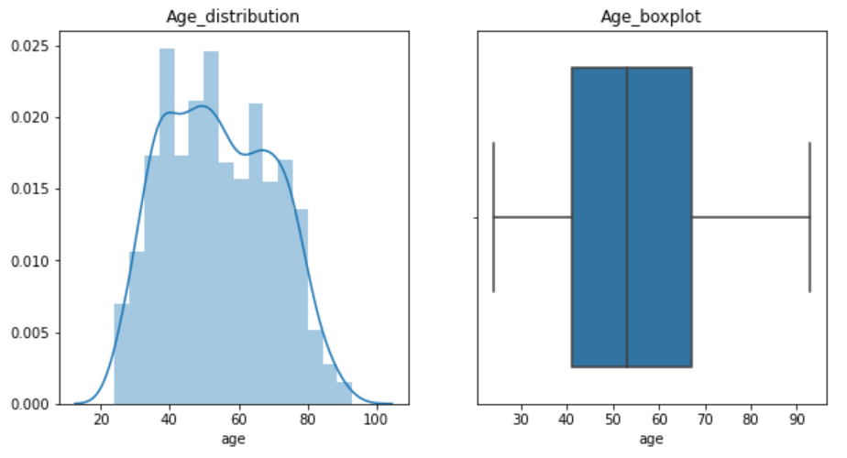

It seems that Age is normally distributed and not much skewed, all age groups are covered, it has no outliers as well.

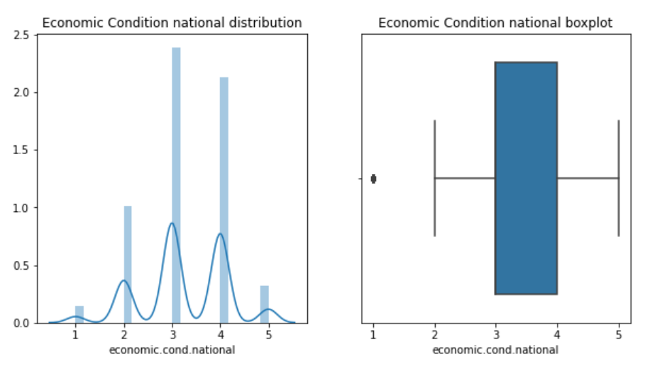

In above plot we can see spikes at almost every rating, but even this is showing most people have given 3 ratings. Very less people have given 1 and 5 rating, from this we can say that this particular nation neither have great economic condition nor poor condition.

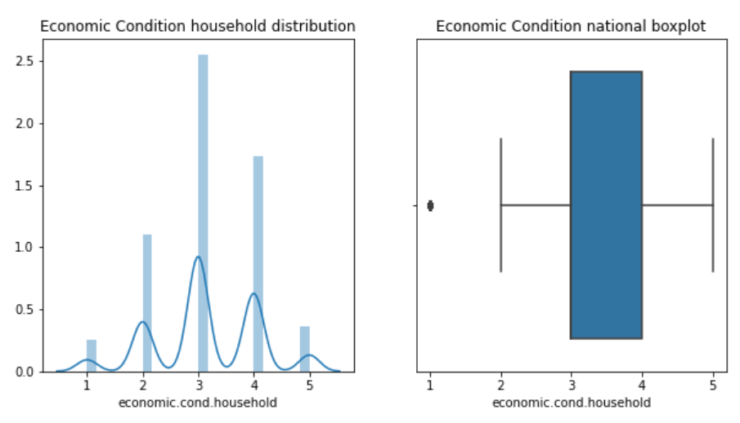

In above plot we can see spikes at almost every rating, but even this is showing most people have given 3 ratings. Very less people have given 1 and 5 rating; from this we can say that this particular nation's people neither have great economic condition nor poor condition.

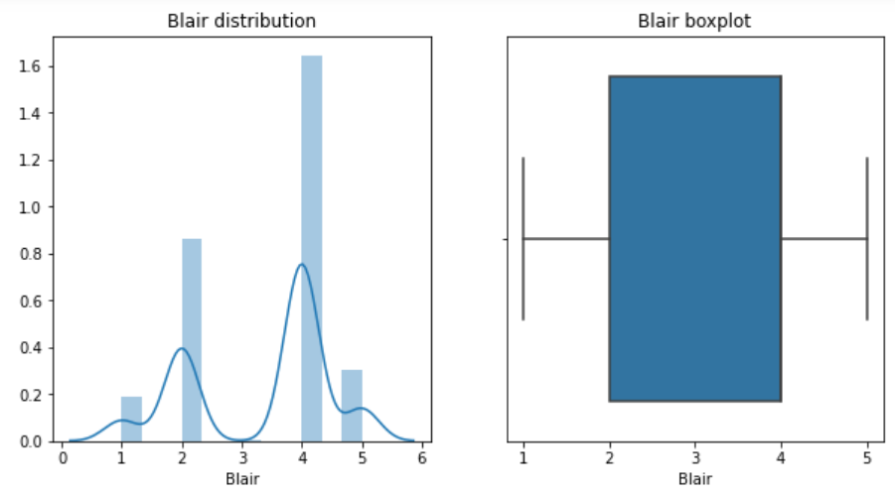

Labour leader Blair has received 2 and 4 score mostly.4 is the highest frequency.

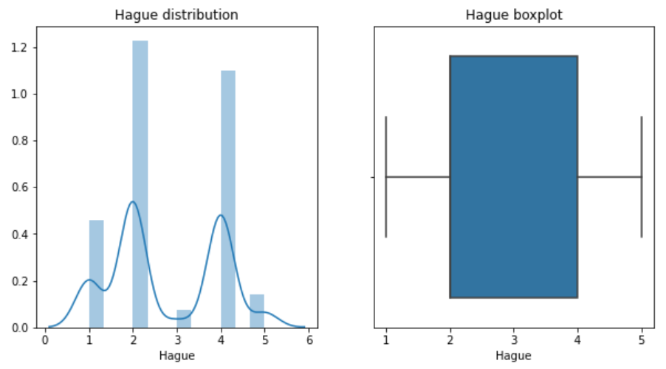

Conservative Party leader Hague has received 2 and 4 score mostly.2 is the highest frequency.

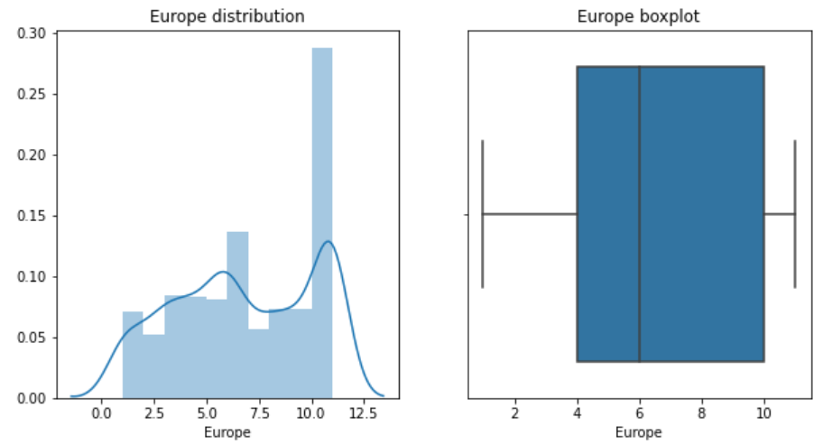

From the Europe plot, the 50% people have rated 4-10 it means they have Eurosceptic sentiment in increasing order.

10 score seems to be have Highest Frequency here; it says that most of the people are against Europe Integration.

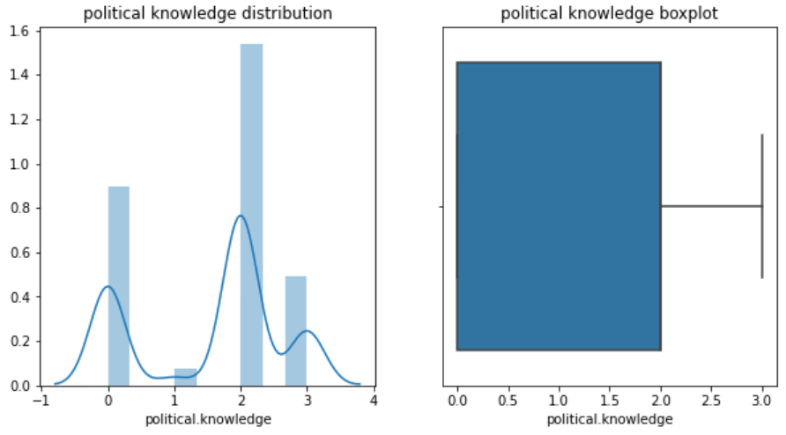

Only around 25% People have average to High political knowledge, 75% people have less Political Knowledge 0,1,2.

Outliers: Economic Household conditions and National Household conditions, Rating 1 is outlier as very less number of people has given it. But we will not treat this value as these are valid outliers, we will keep it.

**Bivariate Analysis**

Scatterplot of Europe vs. Age

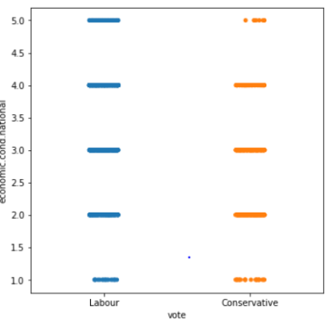

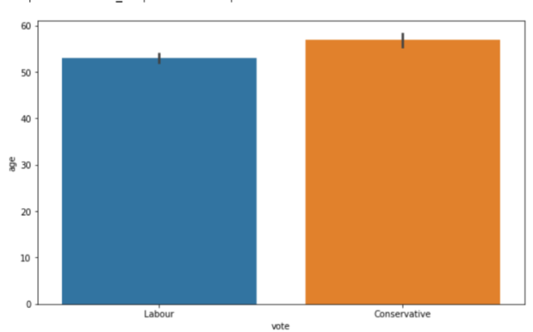

Higher Europe (Eurosceptic) score, it has converted into vote to the Conservative Party.

All age group people are voting to both the parties, so it is no more age specific, But Euro Skepticism is playing important role here

Almost all age groups are voting to Labour and Conservative Party.

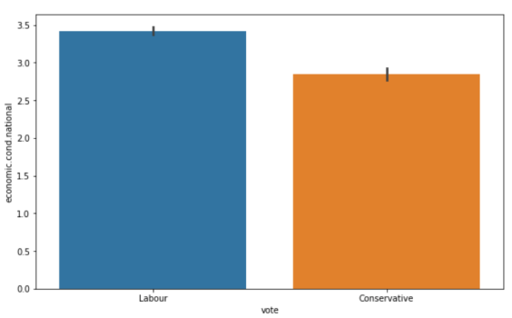

People who are giving good assessment score on National Economic condition are tend to give vote to Labour party, while lesser score turn into vote to Conservative party, this is not the case always happens.

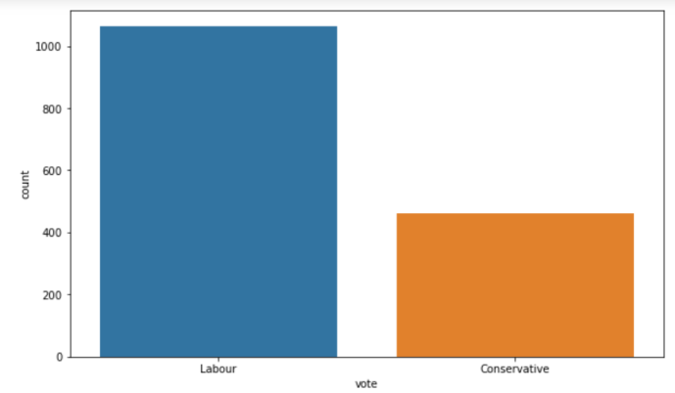

This data has more than 1000 readings who are voting to Labour party while less than 500 who are voting to conservative party it is unbalanced data, might affect to prediction of model.

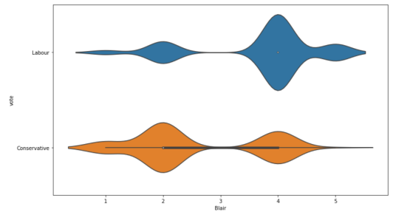

If person’s rating is high to Blair as a party leader, vote will be mostly go into Labour Party's basket. while low Blair score convert the vote into Conservative Party Favor.

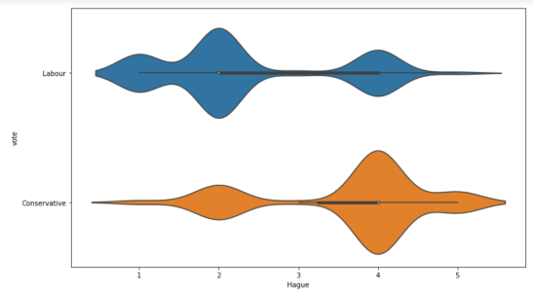

If person’s rating is high to Hague as a party leader, vote will be mostly go into Conservative Party's basket. while low Hague score convert the vote into Labour party Favor.

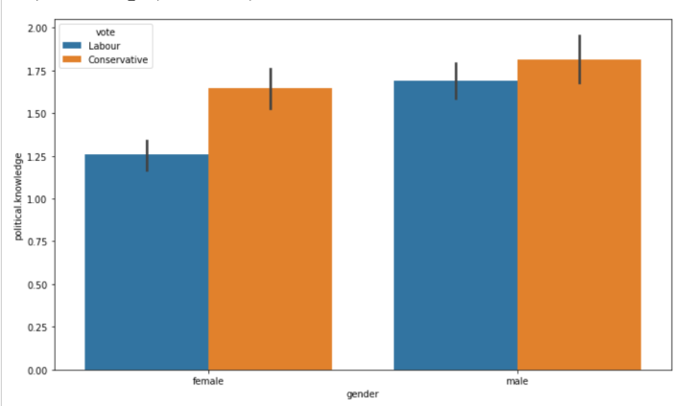

Political Knowledge of Males seems to be higher than average knowledge of females. In both cases higher political Knowledge people are voting to Conservative Party.

**Pair plot** :

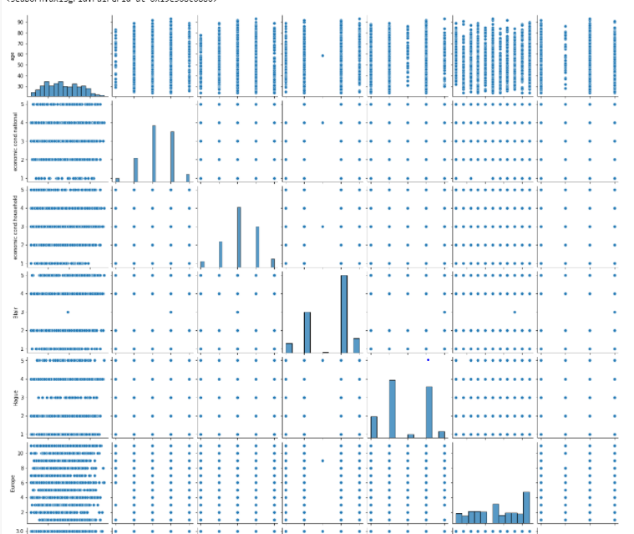

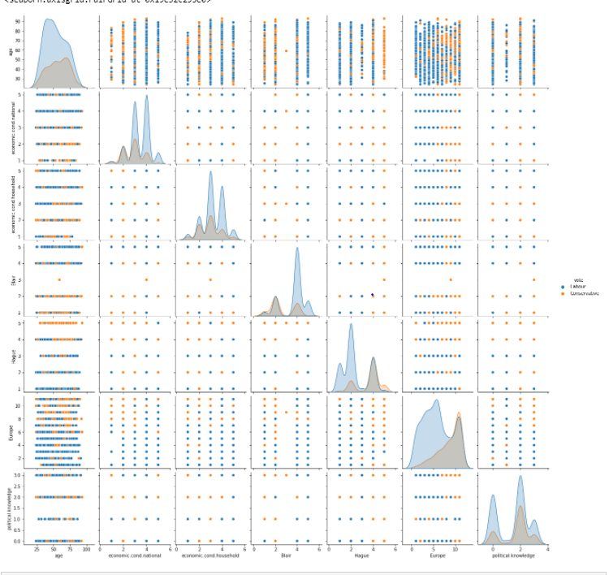

Heat map for correlation:

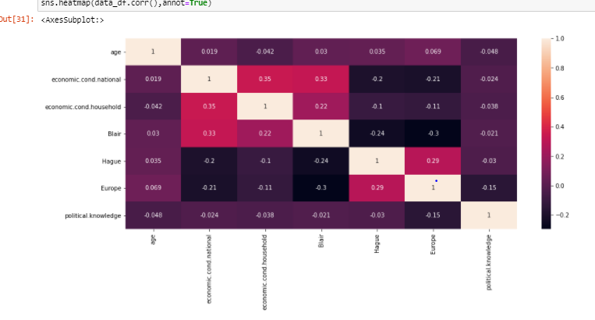

Blair and Economic Household Condition Rating, Economic national Condition rating shows good correlation.

Europe and Blair are inversely related, means if Person is more Eurosceptic there will be less chances he will vote to Blair as a party leader of Labour party

If person is giving good assessment score to Hague he must be with Conservative party and he or she is Highly Eurosceptic.

It is not always true, but people having good political Knowledge prefer Europe Integration.

### Problem 1.3

Encode the data (having string values) for Modelling. Is Scaling necessary here or not? Data Split: Split the data into train and test (70:30).

**Resolution:**

We have to encode the features vote and Gender, to feed the data to model.

Here vote and gender are Nominal Categorical variables, we can use one hot encoding to feed data to model.

We will use get dummies function to convert data into 0’s and 1’s.

vote_labour=1 ; Vote has been given to Labour Party.

vote_labour=0 ; Vote has been given to Conservative Party.

gender_male=0; Female

gender_male=1; male

After Scaling, the first 5 rows,

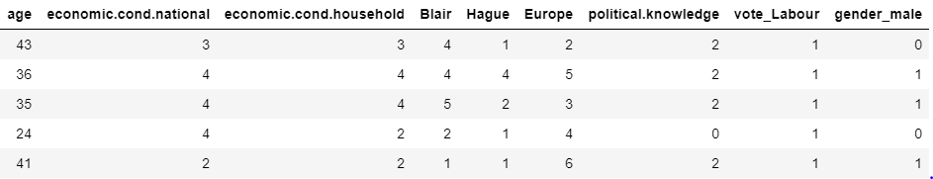

All features are having different ranges and different scales like somewhere it is 1-11, 0-4 etc.

We will do scaling for KNN only.

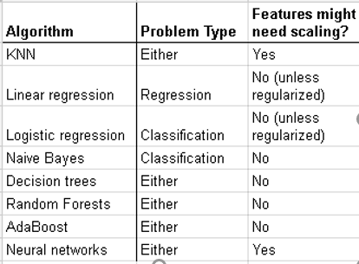

Data Split

Split the data into train and test (70:30).

We will calculate VIF to see if there any issue of Multicollinearity or not.

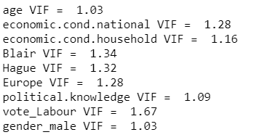

All VIF score is less than 4 hence no issue of Multi-collinearity.

Let’s copy all the predictor variables into X data frame. And copy target into the y data frame.

Split X and y into training and test set in 70:30 ratios.

We have created 4 variables here, X_train, X_test, y_train, y_test.

We will check the distribution percentage for target variable in train and test data.

Train target variable:

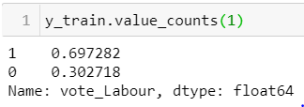

**Test Target variable:**

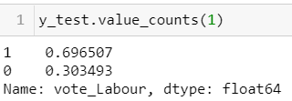

Almost 70-30 is the distribution of vote is achieved, as original dataset is also contains 70:30

Labour: Conservative distribution.

### Problem 1.4

Apply Logistic Regression and LDA (linear discriminant analysis)

**Resolution:**

**Apply Logistic Regression:**

First we will create Logistic Regression and then we will fit it on train data **X_train, y_train.**

We will use solver as ‘newton-cg’ with 10,000 iterations.



Predicting on Training and Test dataset



Getting the probabilities:



First 5 rows of Predicted probabilities.

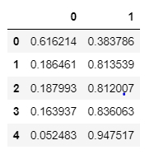

Apply Linear Discriminant Analysis:

**Build LDA model**

We will create LDA classifier and then we will fit it on training data *X_train, y_train.*



Then we will predict the values on train and test data *X_train , X_test.*

With a cut off value 0.5

### Problem 1.5

Apply KNN Model and Naïve Bayes Model. Interpret the results

**Resolution:**

Here we have to note one thing is data is not scaled, and KNN algorithm is sensitive to this kind of data, so we will scale the data using *Z-score* before feeding to the model.

We will import zscore from scipy.stats

After applying z score to the data, and after scaling all the dependent variables,

Data is converted from -1 to +1.

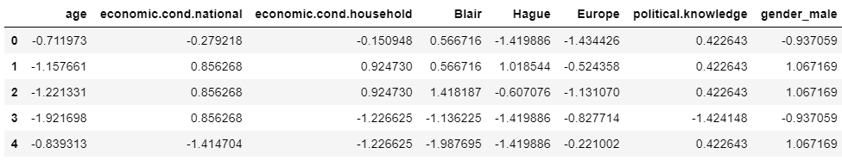

From *sklearn.neighbors* we will import *KNeighborsClassifier.*

then we will create KNeighborsClassifier()

then we will fit it on train data x_train and y_train.

**Apply Naïve Bayes Model:**

From sklearn.naive_bayes we will import GaussianNB

Then we will create Naïve Bayes model and fit it on (X_train, y_train).

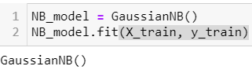

### Problem 1.6

Model Tuning, Bagging (Random Forest should be applied for Bagging), and Boosting

**Resolution:**

**Apply Random Forest:**

For Bagging we will use Random Forest algorithm as Suggested.

First we will import RandomForestClassifier from sklearn.ensemble.

Then we will create Random forest Classifier with n_estimators as 100.

**n_estimators** : This is the number of trees we want to build before taking the maximum voting of predictions. Higher number of trees gives better performance.

Then we will fit the model on (X_train, y_train) dataset.

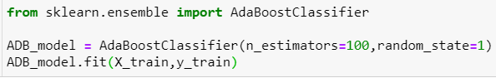

**Apply Bagging**

Here we will create Bagging Classifier, Where we will select trees as 100, and base

Estimator as Classification and Regression tree.

Then we will fit the model on train data

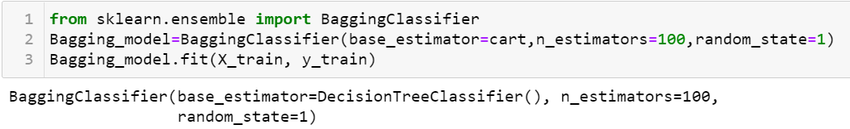

Ada boost

First we will import AdaBoostClassifier from sklearn.ensemble library.

Then we will create Ada boost model.

Then we will fit the model on (X_train, y_train) dataset.

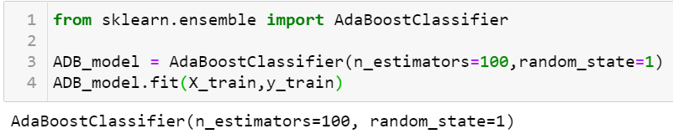

### Problem 1.7

Performance Metrics: Check the performance of Predictions on Train and Test sets using Accuracy, Confusion Matrix, Plot ROC curve and get ROC_AUC score for each model. Final Model: Compare the models and write inference which model is best / optimized.

**Resolution:**

So far we have created and trained the models Logistic Regression, LDA, Naive Bayes, KNN, Random Forest, Ada boost on Training data set. Now we will check Performance of all of them.

1. **Logistic Regression**

**Accuracy and AUC-ROC:**

On Train data:

83% is the Accuracy on train data.

AUC and ROC curve for training data:

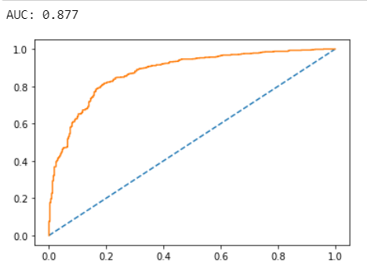

On Test data:

84.93% is the Accuracy on train data.

AUC and ROC curve for training data:

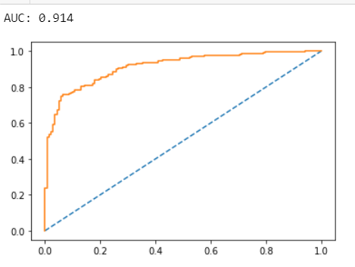

**Confusion Matrix**

On Train data

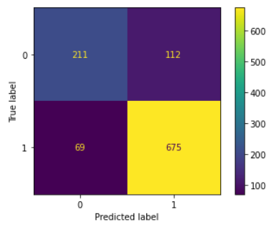

On Test Data : Confusion Matrix,

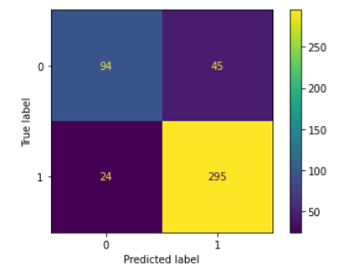

**Classification Report**

On Train data:

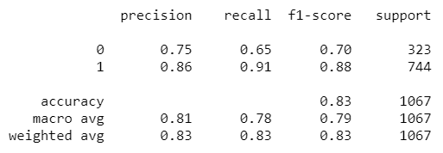

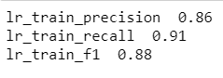

On Test Data ,

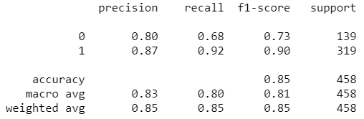

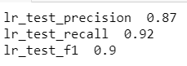

We can see both 0’s and 1’s are equally Important here, because vote to both leaders matter to us. Logistic Regression has performed really well no over fitting issue can be Observed here.

Precision, recall and f1 score to predict 0, is 75%, 65% , 70% on Train data.

It has 83%-84% Accuracy on test data, while f1 score is also 88-90%.

1. **Linear Discriminant Analysis**

**Accuracy and AUC-ROC:**

On Train and Test data:

83% and 85% is the Accuracy on train data and test data respectively.

AUC and ROC curve for training and test data:

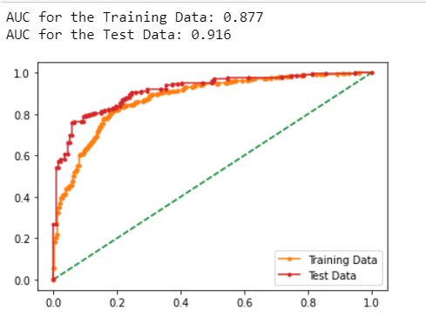

**Confusion Matrix for LDA:**

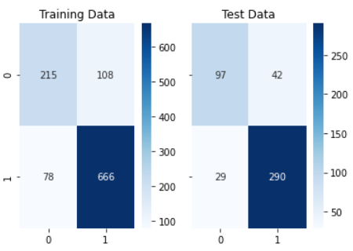

**Classification Report for LDA:**

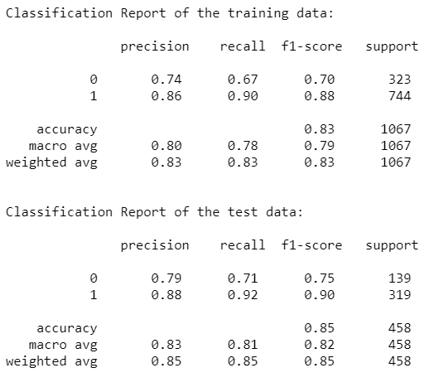

LDA has also performed really well no over fitting issue can be Observed here. On Test data and train data only + - 2% is the difference.

To Predict 0, the precision, recall and f1 score has fallen as compare to Predict 1.

It has 83%-85% Accuracy, while f1 score is also 88-90%.

1. **K Nearest Neighbour**

**Accuracy and AUC-ROC:**

On Train data:

87% is the Accuracy on train data.

82% is the Accuracy on test data.

AUC and ROC curve for and test data:

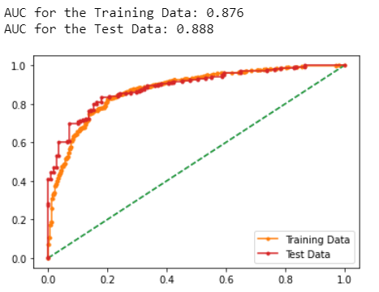

**Confusion Matrix for KNN:**

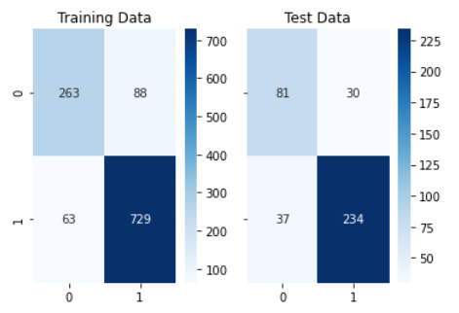

**Classification** **Report for KNN :**

Classification report for training data:

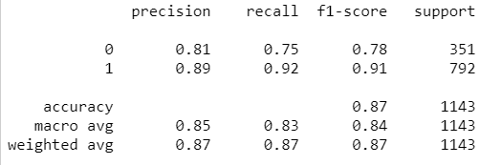

Classification report for test data:

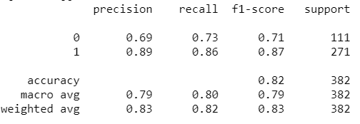

Here in KNN we can see the value is little lower in case of test data

Accuracy and f1 score, but again even this model will perform well,

We need to hyperparameter tuning to improve performance.

It is predicting 1 with higher f1 score but it is showing poor performance to predict 0.

1. **Naive Bayes Algorithm**

**Accuracy and AUC-ROC:**

On Train data:

82% is the Accuracy on train data.

84% is the Accuracy on test data.

AUC and ROC curve for train and test data:

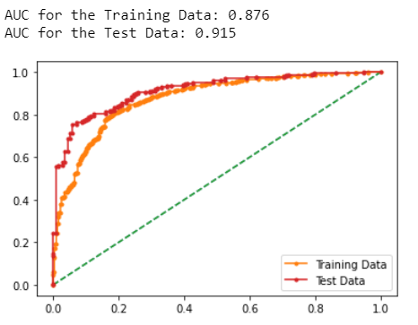

**Confusion Matrix:**

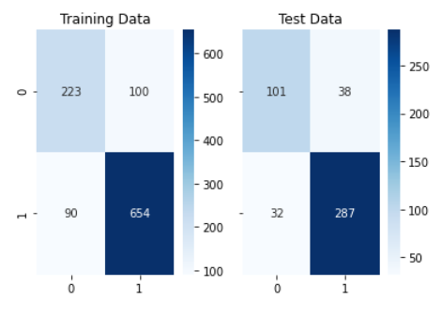

**Classification Report for Naïve Bayes Algorithm:**

On Train data:

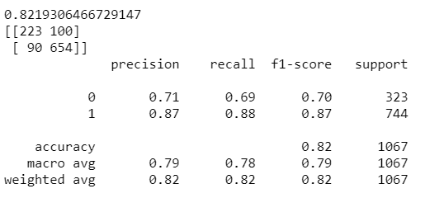

On Test Data:

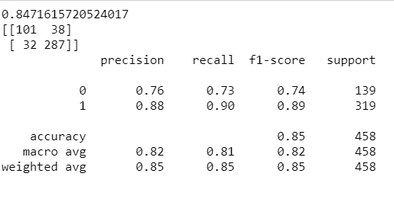

We need hyper parameter tuning to improve performance.

It is predicting 1 with higher f1 score but it is showing poor performance to predict 0.

**Random Forest**

**Accuracy and AUC-ROC:**

On Train-test data:

100% is the Accuracy on train data.

85% is the Accuracy on test data.

AUC and ROC curve for train and test data:

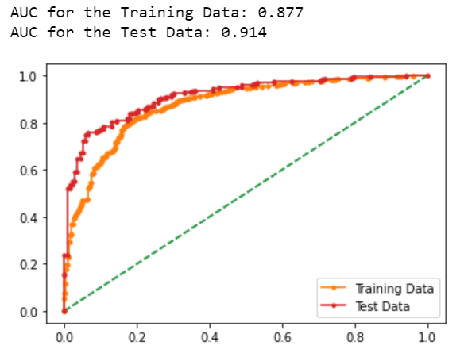

Confusion Matrix for Random Forest:

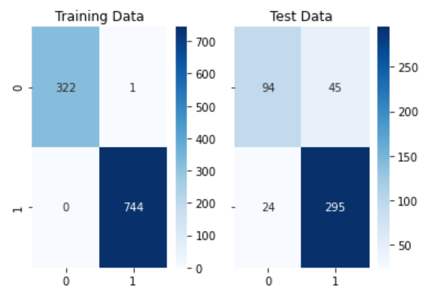

Classification Report for Random Forest:

On Train Data:

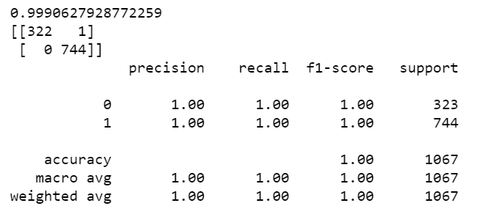

On Test Data:

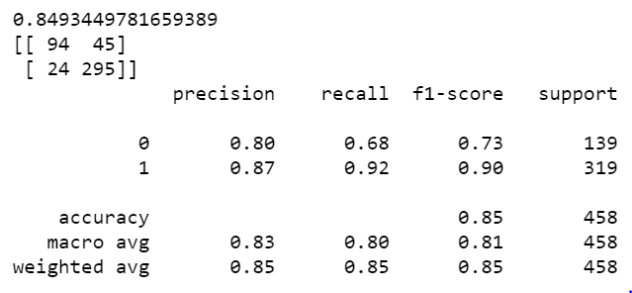

Random Forest is clearly an over fitting one, as almost all metrics has reduced on test data.

1. **Bagging**

**Accuracy and AUC-ROC:**

On Train-test data:

99.7% is the Accuracy on train data.

91.8% is the Accuracy on test data.

AUC and ROC curve for train and test data:

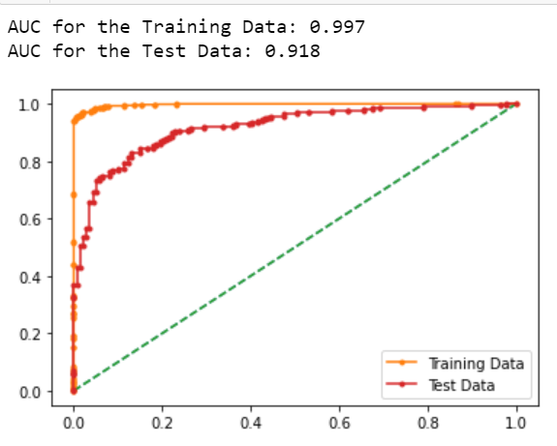

Confusion Matrix for Bagging :

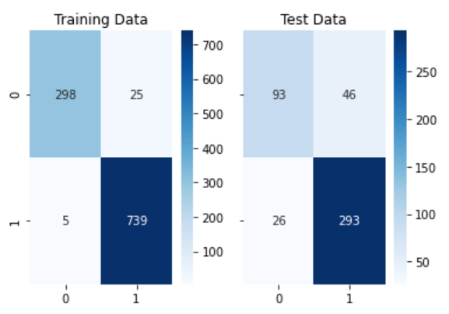

Classification Report for Bagging:

On Train Data,

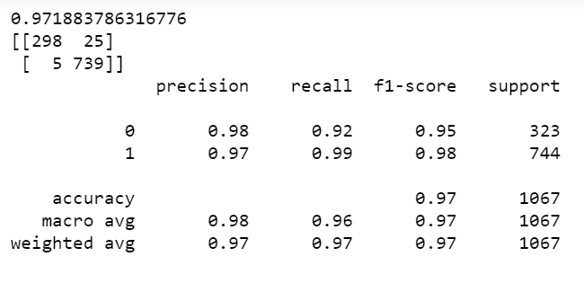

On Test data,

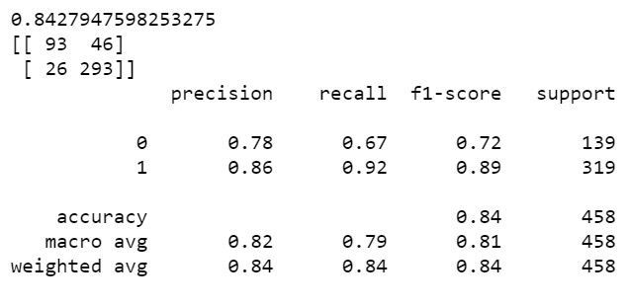

Model has stability in predicting 1 while Predicting 0, Bagging Model is Over fitting.

1. **Ada Boost**

**Accuracy and AUC-ROC:**

On Train-test data:

84.5% is the Accuracy on train data.

83.62% is the Accuracy on test data.

AUC and ROC curve for train and test data:

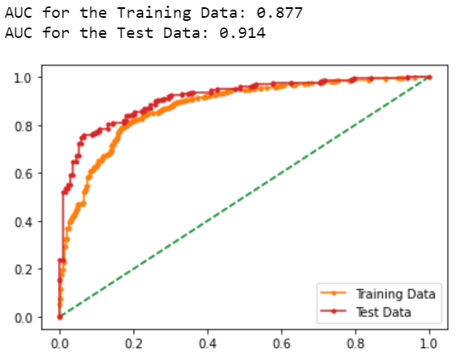

Confusion Matrix for Ada Boost:

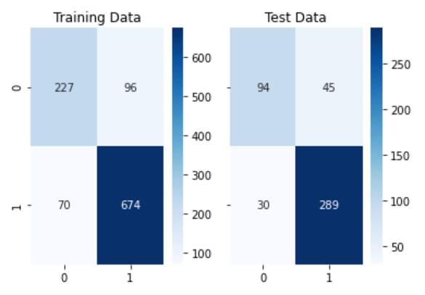

Classification Report for Ada Boost:

On Train Data,

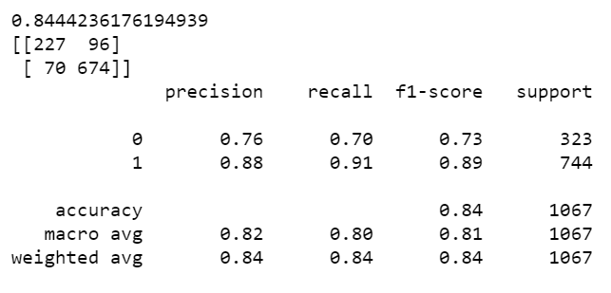

On Test Data,

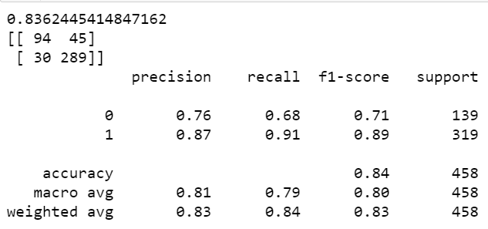

Model is Performing well as compare to other models.

**All Model Comparison by its performance metrics:**

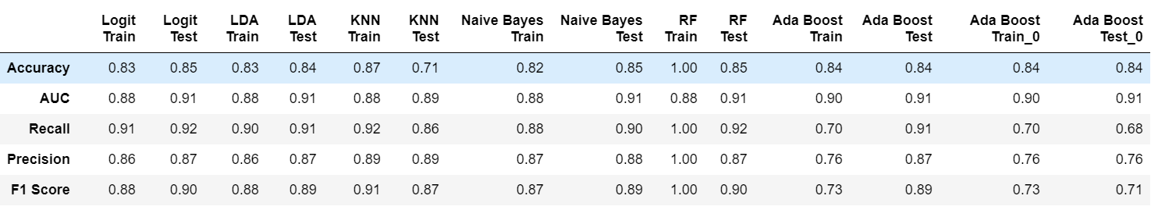

Now the Train data seems to be unbalanced, like 30-70% Conservative Party and Labour party votes, so we will use SMOTE oversampling method on train data here to balance the Data.

Naive Bayes with SMOTE

Performance metrics for Naive Bayes with SMOTE:

On Train Data:

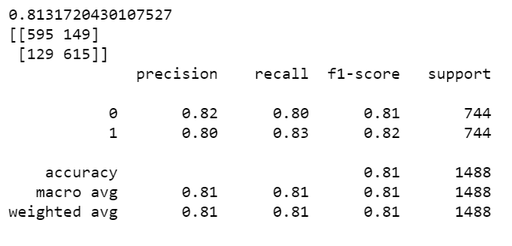

On Test Data:

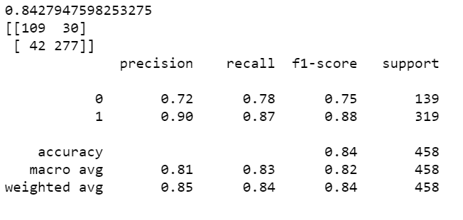

Model is overfitting here, so we will see what happens with SMOTE and Ada Boost, Linear Regression.

SMOTE with Ada Boost:

**Classification Report:**

On Train Data,

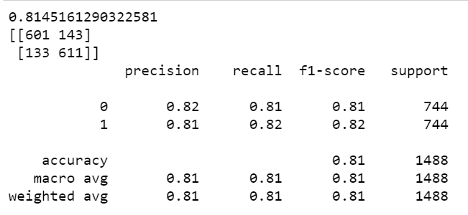

On Test Data,

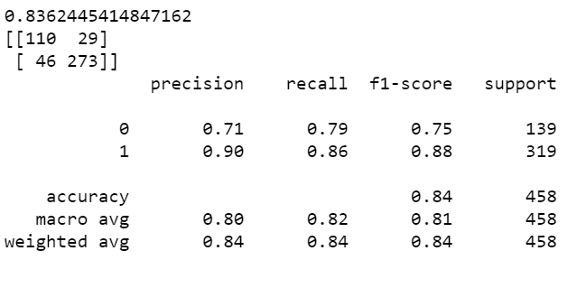

This is again over fitting / under fitting issue while predicting 0’s and 1.

SMOTE with Logistic Regression:

Classification Report:

On Train Data,

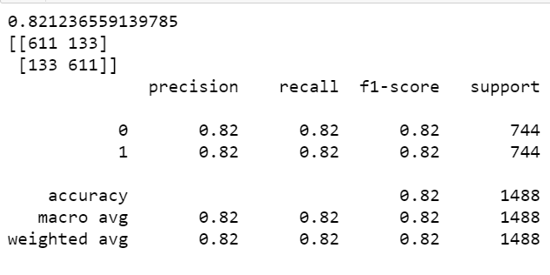

On Test Data,

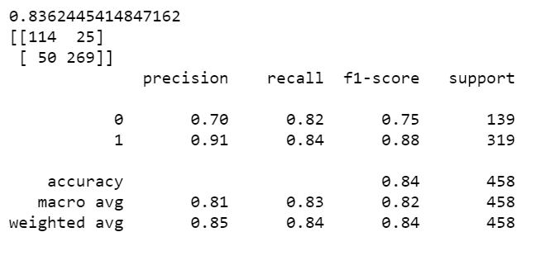

Not exactly but Logistic Regression seems much stable as Compare to other models, after applying SMOTE-balanced data.

Model Tuning:

Now we will use Model tuning for various Algorithms to check whether the performance is Improving or not by changing its hyper parameters.

#### **For Naive Bayes Model, will use K-fold validation how model performs on Limited dataset.**



***Average Score is 0.82, which is good score, it is performing well.***

#### Let’s check using GRID search, for KNN

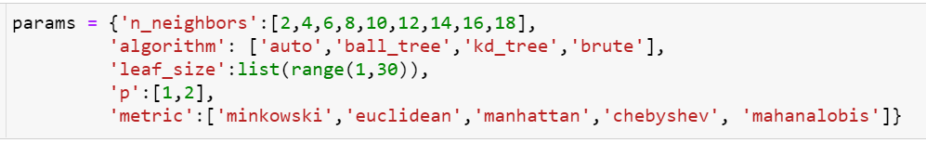

**We are here using different distance metrics, P value is**

When p = 1, this is equivalent to using manhattan_distance

P=2,Power parameter for the Minkowski metric.

We are selecting leaf size from 1 to 30, to get the optimal value.

Before fitting the data, we are scaling train data by using z score

Scaled data:

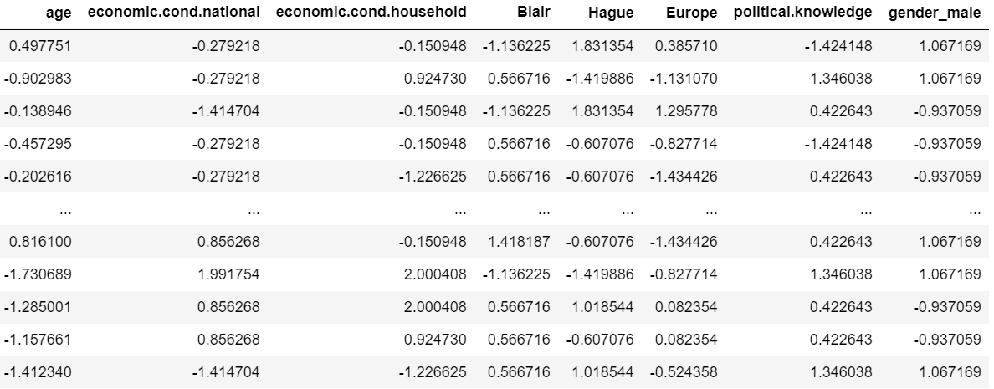

The values set for algorithm,

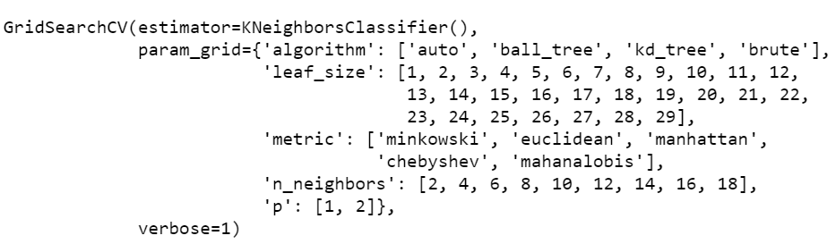

These are the best Parameters for KNN:

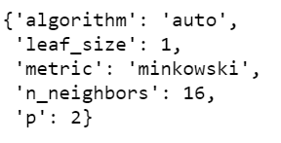

Train and Test Accuracy for KNN after Grid Search CV.

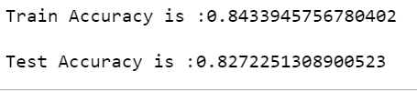

***It is almost same as earlier.***

#### Lets check using GRID search, for Logistic Regression and Random Forest

We will import Pipeline from sklearn.pipeline library.

In this we will create two Classifier – Logistic Regression and Random Forest will see the best performing model with its best Parameters.

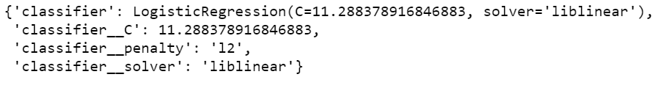

*Logistic Regression Classifier is giving best results, with Solver Liblinear*

*With Classifier Penalty as Ridge.*

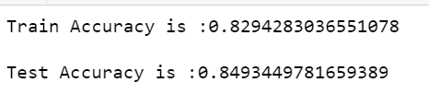

Classification Report:

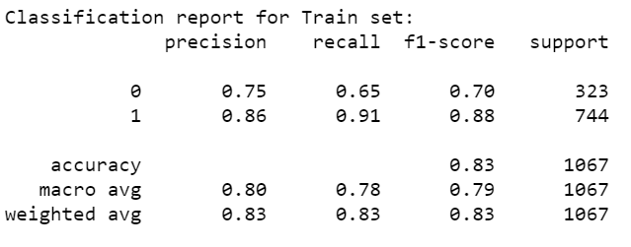

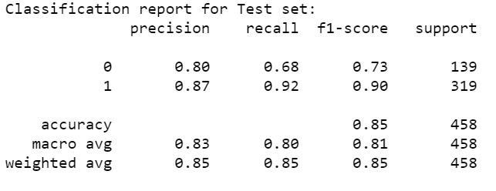

The Logistic Regression is Performing well on Test data and Train data, it seems to be stable. It is predicting 0 and 1 clearly.

It has low scores while predicting 0 but for 1 Precision, Recall and F1 is good on both train and test data.

Prediction of 0 i.e vote to conservative Party, prediction is little tougher as there is very less data points conveying vote to Conservative Party. This can be minimized if we ask for more data.

If we check the first 10 votes, It is clearly, mentioning the vote to Labour party.



First 400 votes,



Here out of 400, 96 votes are to the Conservative party and 304 votes are to the Labour party so clearly it is indicating the Labour party will win.

Again there are some assumptions and data limits we have, so as of now this is the scenario.

### Problem 1.8

Based on these predictions, what are the insights?

##### Steps Performed and Insights:

To predict results, we have started with Exploratory data Analysis where we got some hidden insights by looking at Dataset, by using univariate analysis, Multivariate analysis. Null value, Outlier detection. From EDA we have drawn below mentioned Insights:

Assessment to leader Blair and Economic Household Condition Rating, Economic national Condition rating shows good correlation.

If person is giving good assessment score to Hague he must be with Conservative party and he or she is Highly Eurosceptic.

It is not always true, but people having good political Knowledge are preferring Europe Integration.

***Modelling***

As **the** target variable here is Categorcal i.e Conservative and Labour, we can use Logistic Regression, LDA, KNN, Naive Bayes, RF, Bagging, Boosting.

After all this we have created a Final Classification report where all performance metrics are mentioned.

We have used all mentioned Algorithms. If we check the Target Variable we have almost 70% data of Labour Party and 30 % Conservative Party. We have built all algorithms on this data first, after this we have used SMOTE technique of Oversampling to balance Imbalanced data. We can see in the Classification report that Accuracy, Precision has been dropped.

After all this to do Model tunning we have used Gridsearch CV, K fold cross validation to Improve performance of Existing Base models.

##### *Results:*

To get the crystal clear picture, we need more data points to avoid Imbalance data issue. but from this data, we can say that to win the election one must be with vision Europe integration, as this vision has helped labour party.

The Model Logistic Regression has good score and seems to be very stable model in this Scenario. If we predict on Test Data, The labour Party seems to be get Higher number of Votes as compare to Conservative Party. Again the question arises here does this sample represent the whole nation, any bias in the data, like from Particular region data is collected where Labour Party has higher influence. There are less votes to Conservative party, but again it needs more data to predict correct results. But as of now this data tells us that Labour party will win these elections.

*****************************************^^^^^^^^^^^^^^^^^^^^^^^^^^^^^^^^^^^^^^^^^^^^*************************************

## Problem 2:

In this particular project, we are going to work on the inaugural corpora from the nltk in Python. We will be looking at the following speeches of the Presidents of the United States of America:

1. President Franklin D. Roosevelt in 1941
2. President John F. Kennedy in 1961
3. President Richard Nixon in 1973.

### Problem 2.1

Find the number of characters, words, and sentences for the mentioned documents.

**Resolution:**

The number of characters for Roosevelt is: 7571

The number of words for Roosevelt speech is: 1323

The number of sentences for Roosevelt speech is: 68

The number of characters for John F. Kennedy is: 7618

The number of words for John F. Kennedy speech is: 1364

The number of sentences for John F. Kennedy speech is: 52

The number of characters for John F. Kennedy is: 9991

The number of words for John F. Kennedy speech is: 1769

The number of sentences for John F. Kennedy speech is: 69

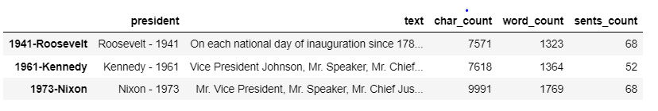

### Problem 2.2

Remove all the stop words from all three speeches.

**Resolution:**

Download stopwords from nltk

After removing stop words from Franklin D. Roosevelt

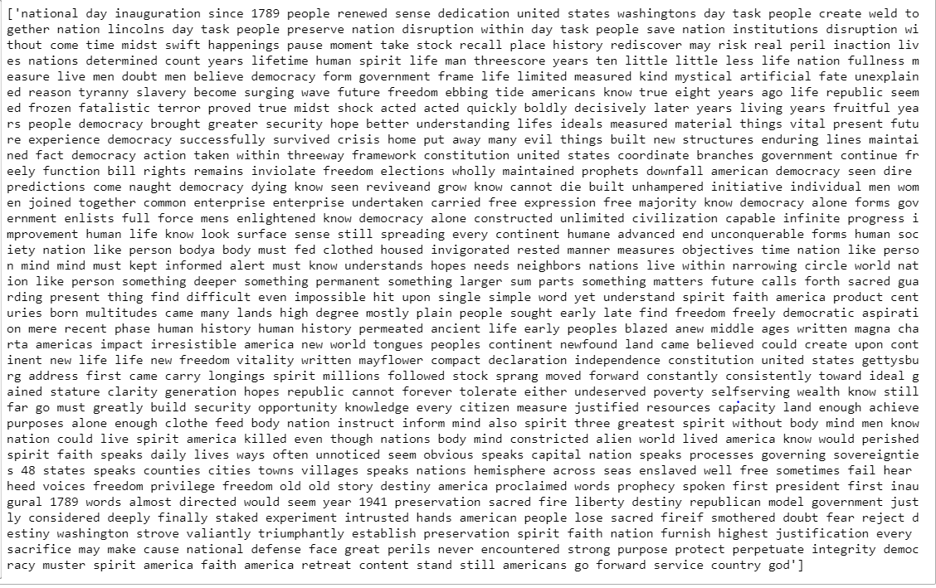

After removing stop words from John F. Kennedy

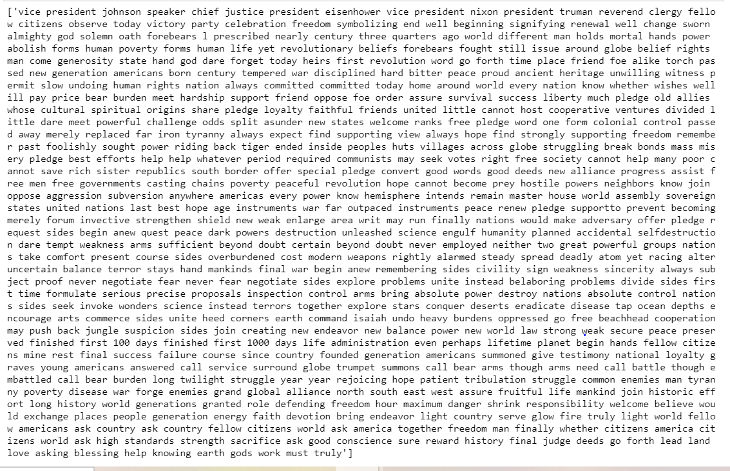

After removing stop words from Richard Nixon.

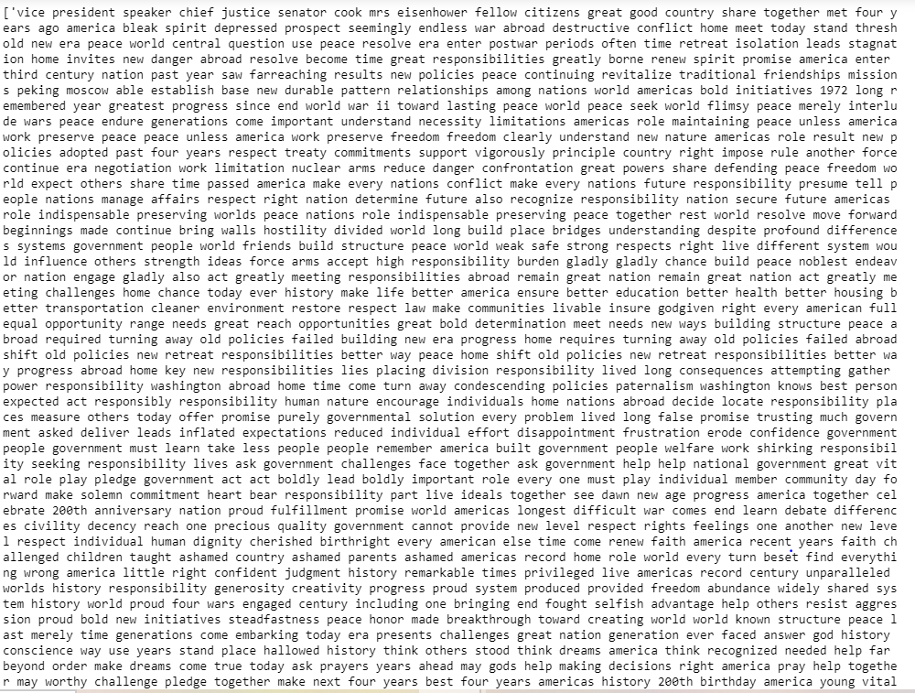

### Problem 2.3

Which word occurs the most number of times in his inaugural address for each president? Mention the top three words.

(After removing the stopwords)

**Resolution:**

Words that occurs the most in speech Franklin D. Roosevelt isNation

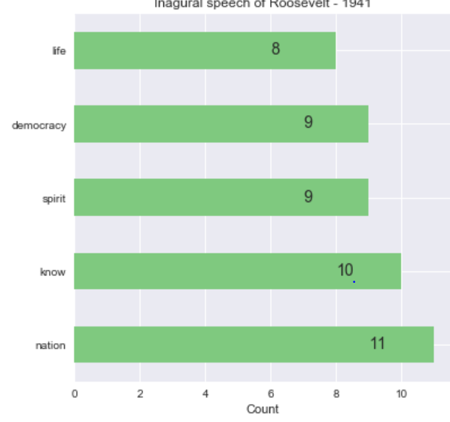

Words that occurs the most in speech Kennedys Speech is Sides and world

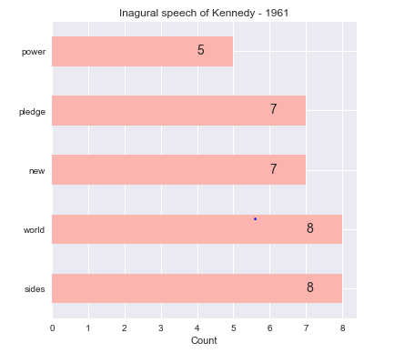

Words that occurs the most in speech Richard Nixon is peace:

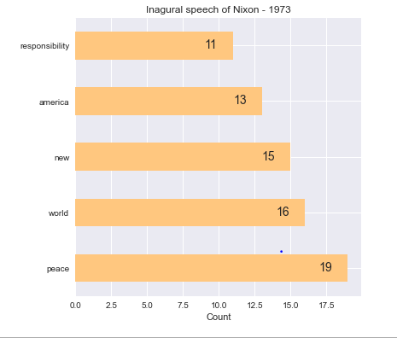

### Problem 2.4

Plot the word cloud of each of the speeches of the variable. (After removing the stopwords)

**Resolution:**

WordCloud for Franklin D. Roosevelt

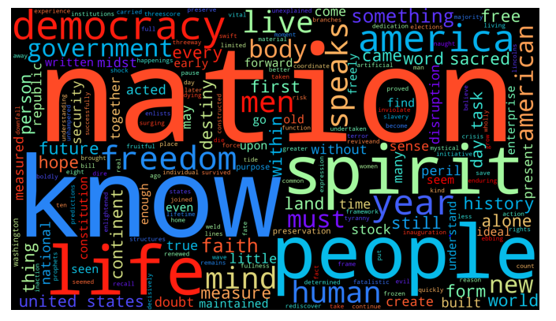

WordCloud for John F. Kennedy



WordCloud for Richard Nixon



The End

Thakur Arun Singh

*****************************^^^^^^^^^^^^^^^^^^^^^^^^^^^^^^^^^**************************